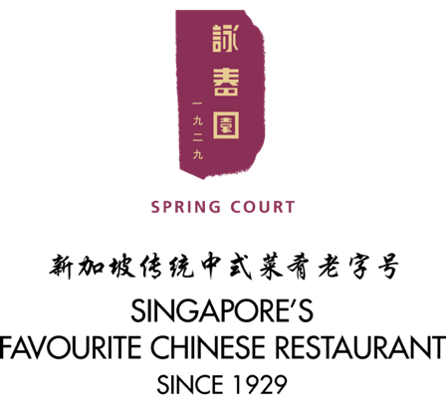

**Complimentary $50**

**Cash Voucher**

for every

90th **Anniversary**

**Celebration Menu**

90周年店庆套餐大优惠

将获回扣$50现金礼券

52-56 Upper Cross Street

Singapore 058348

Tel:6449 5030 Fax: 65356609

|  |  |  |  |
| --- | --- | --- | --- |
| |  |  | | --- | --- | | **$638++** | **10人套餐** | | **Set for 10 Pax** | |

|  |
| --- |
| **赠送北京片皮鸭一只**  **FOC BBQ Whole**  **Peking Duck**  五福大拼盘  Appetizer Combo Platter  红烧蟹黄翅  Braised Shark’s Fin with Crab Meat  豉蒸金目鲈  Steamed Live Sea Bass in Black  Bean Sauce  脆皮烧鸡  Roasted Whole Chicken  佛钵飘香  Crispy Yam Ring Topped with  Prawn and Assorted Vegetable  小笼蒸游水虾  Quick Boiled Prawns in  Bamboo Basket  鲍汁三丝焖面  Braised Noodles with Shredded  Chicken in Abalone Sauce  莲子红豆沙  Red Bean Cream with Lotus Seeds |

*Valid from 20 February till 31 October 2019

* Complimentary $50 Cash Voucher Promotion is not applicable on 14th, 15th and 16th June (Father’s Day)

*Not valid with other Promotions, Discount, Vouchers, Coupons & Privilege Club Points & Vouchers Redemptions

*All prices subject to 10% service charge & 7% GST

|  |  |  |  |
| --- | --- | --- | --- |
| |  |  | | --- | --- | | **$758++** | **10人套餐** | | **Set for 10 Pax** | |

|  |
| --- |
| **赠送北京片皮鸭一只**  **FOC BBQ Whole**  **Peking Duck** |
| 五福大拼盘  Appetizer Combo Platter  珊瑚蟹肉鱼翅  Shark’s Fin Soup with Crab Meat  油浸游水荀壳  Deep-Fried Live Soon Hock Fish  金龙百花鸡  Roasted Whole Boneless  Chicken Stuffed with Minced Prawn  XO酱带子西兰花  Stir-fried Broccoli with Scallop  And XO Sauce  蒜蓉蒸游水虾  Steamed Live Prawn with  Minced Garlic  鸡蟹干烧伊面  Pan-fried Noodles with Shredded  Chicken in Crab Meat  四宝炖桃胶  Double Boiled Peach Gum  With Four Treasure |
|  |

|  |  |  |  |
| --- | --- | --- | --- |
| |  |  | | --- | --- | | **$888++** | **10人套餐** | | **Set for 10 Pax** | |

**赠送二选一**

* **大红乳猪1只**
* **原只澳洲鲍鱼10粒**

**Choose 1 FOC:**

* **BBQ Whole Suckling Pig**
* **Whole Australian Abalones**

五福大拼盘

Appetizer Combo Platter

珊瑚蟹肉生翅

Superior Shark’s Fin with Crab Meat

油浸游水荀壳

Deep-Fried Live Soon Hock Fish

上汤焗生猛龙虾

Braised Lobster I Rich Stock

金龙百花鸡

Roasted Crispy Chicken Stuffed with

Minced Prawns

XO酱带子西兰花

Stir-fried Scallop and Broccoli with XO Sauce

海鲜干炒面线

Stir-Fried Mee-Sua Noodle with

Assorted Seafood

生磨杏仁茶

Freshly Ground Almond Paste

|  |  |  |  |  |
| --- | --- | --- | --- | --- |
| |  |  |  |  | | --- | --- | --- | --- | | |  |  | | --- | --- | | **$998++** | **10人套餐** | | **Set for 10 Pax** | |   **赠送二选一**   * **大红乳猪1只** * **原只澳洲鲍鱼10粒**   **Choose 1 FOC:**   * **BBQ Whole Suckling Pig** * **Whole Australian Abalones** |
| 龙虾大拼盘  Lobster Combo Platter  红烧大鲍翅  Braised Premium Shark’s Fin in  Brown Sauce  金龙百花鸡  Roasted Crispy Chicken Stuffed  With Minced Prawns  清蒸游水海红斑  Steamed Live Garoupa with  Soya Sauce  黄金杏片虾  Deep-fried Prawns with Almond  and Salted Egg Yolk  XO酱带子西兰花  Stir-fried Scallop and Broccoli with  XO Sauce  三丝面线  Stir-fried Mee Sua with Shredded  Chicken and Mushroom  白果芋泥  Yam Paste with Gingko Nuts |

|  |  |  |  |  |
| --- | --- | --- | --- | --- |
| |  |  |  |  | | --- | --- | --- | --- | | |  |  | | --- | --- | | **$1188++** | **10人套餐** | | **Set for 10 Pax** | |   **赠送二选一**   * **大红乳猪1只** * **原只澳洲鲍鱼10粒**   **Choose 1 FOC:**   * **BBQ Whole Suckling Pig**   **Whole Australian Abalones** |
|  |
| 传统迷你佛跳墙  Traditional Mini Buddha Jumps Over  The Wall  XO酱带子炒芦笋  Stir-fried Asparagus & Scallop in  XO Sauce  荷香麒麟蒸鲳鱼  Steamed Pomfret Fish with Ham &  Mushroom  上汤焗生猛龙虾  Braised Lobster in Rich Stock  传统蟹肉鸿图窝面  Noodle Soup with Shredded Chicken  And Crab Meat  杏仁茶炖雪蛤  Double Boiled Almond Paste with  Hashima  *Valid from 20 February till 31 October 2019  * Complimentary $50 Cash Voucher Promotion is not applicable on 14th, 15th and 16th June (Father’s Day)  *Not valid with other Promotions, Discount, Vouchers, Coupons & Privilege Club Points & Vouchers Redemptions  *All prices subject to 10% service charge & 7% GST |

*** All Price Subject to 10% Service Charge & 7% GST

|  |
| --- |
| **传统干鲍金牌佛跳墙**  **Traditional “Buddha Jumps**  **Over The Wall”**  **$1,380++**  **十人份For 10 Persons** |
|  |
| **九种特选材料**  **Nine Premium**  **Ingredients**  日本吉品鲍鱼  Japanese Dried Abalone  大鲍翅  Superior Shark’s Fin  日本干贝  Japanese Dried Scallop  日本大花菇  Japanese Shiitake Mushroom  金华火腿  Chinese JIn Hua Ham  鳘肚（花胶公）  Dried Fish Maw  菲律宾猪婆海参  Philippines Sea Cucumber  猪蹄筋  Dried Pork Ligament  山芭嫩鸡  Kampong Chicken |

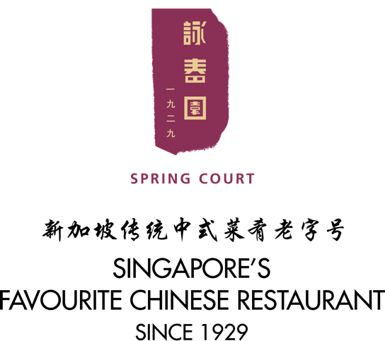

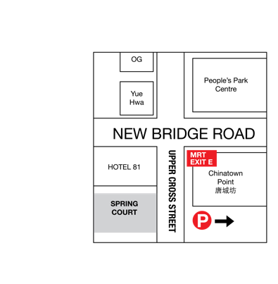

52-56 Upper Cross Street Singapore 058348

Tel:6449 5030 Fax: 65356609

*** Valet Parking Available